CFI INNOVATION FUND 2025
Overview of CFI IF2025 Notice of Intent Requirements

A CFI Notice of Intent (NoI) is due by October 2nd and is required for all IF2025 applications. If the NoI is not submitted, it will not be possible to submit the associated full proposal in February.

CFI does not assess NoIs but intends to do a check on the appropriateness of the Stream selected. There will be an opportunity to adjust the Stream should CFI require it.

Accessing the CFI Notice of Intent

The NoI form is accessed using CFI CAMS. The NoI form must be created by the Project Lead. The Project Lead can then share access to the form, allowing others to edit or view.

In the ‘Researcher Dashboard’ link (top left of screen) create a new application, ensuring you select the appropriate Stream for your proposal, using the drop-down list. This creates the CAMS file and reference # for the NoI and for the Full Application.

The Notice of Intent tabs will be visible, top left of screen, and each tab must be completed.

Project Information
The form asks for basic information about the project.
Under project funding, ensure the total project cost and the CFI share entries are both correct, and the percentage show is no greater than 40%: if it is greater than 40% you will need to adjust the amounts.

Research Security
At the end of the page is a new module for research security. In accordance with new federal research security requirements introduced in the summer, CFI’s application process now asks applicants to either affirm that there are no issues to address, or to provide documents addressing any apparent issues.

You are strongly advised to read CFI’s guidance on research security, as well as the UofT VPRI’s own guidance prior to completing this section.

If you have any queries about federal or provincial research security requirements and how they might apply to your proposal, please contact the VPRI Research Security Team (researchsecurity@utoronto.ca).

The research security module on CAMS looks like this:
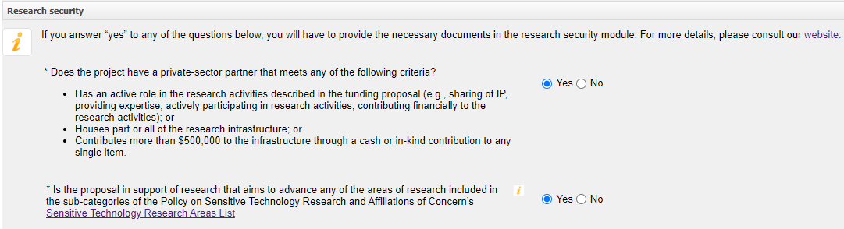
If you answered ‘yes’ to either question, you will be asked to provide additional documentation. The second question will require an attestation by the Project Leader; the first question will require completion of the Risk Assessment Form (RAF). We anticipate that few projects will need to complete the RAF at this stage.
If you answer ‘no’ to both questions, no further action is needed at this stage.

It is recommended that you do not answer ‘yes’ to the first question unless you have a research partner - for example a private sector partner – who is taking an active and collaborative role within the research project. You should not answer ‘yes’ if the ‘partner’ contribution is no more than a vendor discount on a purchase price.

This module will be re-presented in the Full Application should it need to be amended as a result changes to the team membership, or partnerships etc.

If you have answered ‘yes’ to a question you will need to access the Security module to download the required forms, and to upload the completed documents.

Return to the initial ‘researcher dashboard’ and click on ‘application’. You will now see an updated screen:
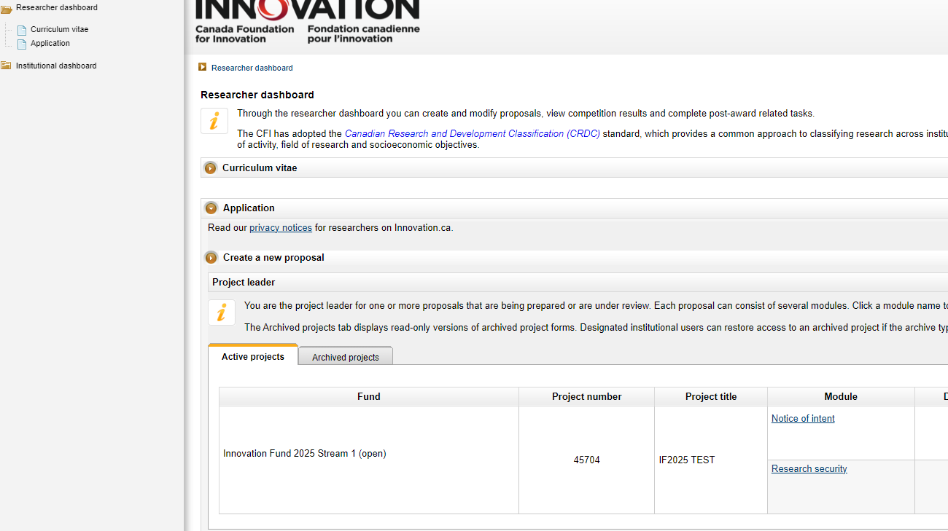

The ‘Notice of Intent’ link is where the basic project information is now entered/edited on the form, and it is also possible to view and download the complete form as a PDF.

The ‘Research Security’ link is where any required attachments (ie the attestation and RAF) may be uploaded. Note that the research security content cannot be viewed as a PDF.

Collaborating Institutions
This is to be completed only if your project will receive an ‘envelope’ contribution from another eligible institution. Input the institution and the known envelope amount: CAMS will automatically issue an invitation to the institution. The NoI will not submit to CFI until the other institution has responded to the invitation.

This section is not to be used to invite Team Members to participate.

Project Summary
Input a 1500-character summary of the project. This text will be used by CFI when it posts the NoIs received. This section will be re-presented in the Full application form.

Team Members
This tab is used to invite the 9 other members of the applicant Team.
The CAMS system will send an invitation to those listed. If they do not already have a CFI account the invitee will need to create an account and a CV: at this stage the CV may be incomplete, but must be complete by November 18th.

You should check response statuses regularly to ensure Team Members respond: the NoI will not submit to CFI if there is an unanswered invitation.

Project Description
Upload a 3-page description of the project as a PDF. Note the formatting requirements.

Suggested Reviewers
Provide information for at least 6 experts able to review your proposal.

Note that CFI is aiming to recruit higher achieving reviewers able to assess the international competitiveness and standing of your research.
Note carefully the potential conflicts of interest listed on the CAMS page and bear in mind that Canada-based suggestions may be associated with other IF applications.

Submitting the NoI: deadline September 27th
Click on the ‘validation’ button to check you have completed all sections. Then click ‘confirm’. This will forward the NoI to RSO. If you discover something in the NoI you wish to change, it is possible to return the NoI to you temporarily.

RSO will submit the NoI to CFI no later than October 2nd.

